# CPSC 4380/5380 (3D Modeling) – Fall 2022

Homework #1

Due: Sunday, October 23

**General**

This homework has 2 parts. Please label each part clearly in your paper. You may include images in your paper.

**Part 1 (10% of grade)**

After reading the document “Getting Lightwave”, obtain Lightwave and install it on your computer. Alternatively, you can work on Lightwave in the Lamar Maes building room 218 lab.

You will find the documentation for Lightwave in the Lightwave docs folder. The file is named Lightwave2015.pdf. The folder location on your computer depends on the installation. A good place to look is:

C:\Program Files\Newtek\Lightwave_2015.3\docs

If you cannot find the documentation file a PDF version is available in Blackboard.

The Lightwave documentation is very useful, especially when learning Lightwave. To get experience with finding a topic in Lightwave, search the documentation for information about the Surface Editor dialog. This is an important dialog you will use often. The page in the documentation you are looking for will have an image something like Figure 1.

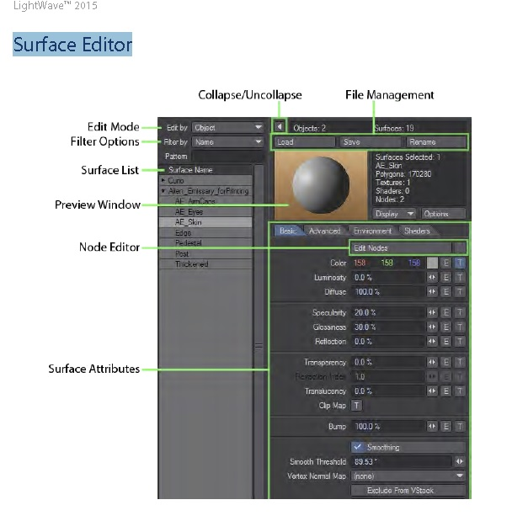

**Figure 1: Lightwave Surface Editor dialog**

Once you find the page in the documentation describing Surface Editor, capture a screenshot of the entire page in the documentation containing the image shown in Figure 1. You can use the Print Screen key on your keyboard to capture a screenshot. You can then open an image editing program like Microsoft Paint, create a new file and paste your screenshot into the image by pressing Ctrl-V. You can then save that image as a JPG or PNG file and later import that image into a text document such as a Word or PDF file.

**Part 2 (90% of grade)**

Watch the video for this week and answer the following questions as completely as you can.

**1) List three 3D popular 3D modeling programs mentioned in the video.**

**Ans:**

Light Wave,3DS studio and Cinema4D are the 3D popular 3D modeling programs.

**2) What is the difference between real-time and non-real-time computer graphics?**

**Ans:**

**Real-time computer:**

Real-time computer graphics are the ones which will be used in the computer applications or any real time applications which will run at least 30 frames per second and these are the sub-field of [computer graphics](https://en.wikipedia.org/wiki/Computer_graphics) focused on producing and analyzing images in [real time](https://en.wikipedia.org/wiki/Real-time_computing). These graphics needs to render very fast.

**Non-Real-time computer:**

Real-time computer graphics are the ones which will be used in the fields like the graphics in the films where rendering wont be quick and its main goal is to be realistic output and these graphics needs not to be rendered fast.

**3) Which type rendering (mentioned in question 2, above) is suitable for computer games that use 3D graphics?**

**Ans:** Real-time computer 3D graphics are the best suitable for computer games as they renders very fast.

**4) Which type rendering (mentioned in question 2, above) is suitable for feature films that use 3D graphics?**

**Ans:** Non-real-time computer 3D graphics is suitable for feature films because these will concentrate on realistic output.

**5) What is the difference between stylized and realistic graphics rendering?**

**Ans:**

**Realistic graphics rendering:**

Realism graphics rendering means realistic graphics that mimic realism. Many of the particularly popular games appear very realistic. They have more vibrant colors, light and atmosphere than similar environments we see in everyday life, with more perfect weather and lighting conditions. If you need vivid visuals to communicate an idea, or to showcase what exactly the project would look like, Realistic 3D Render is the way to go.

**stylized graphics rendering:**

In Stylized [3D visualization](https://www.ilustraviz.com/category/3d-visualization/), 3D artists have much more creative freedom, than they do with Realistic 3D Rendering. With stylization, we will have the flexibility to play with shapes and colors, exaggerate or remove details, and modify the look and feel in any direction. These approaches look similar, but their results are now different due to the absence of restrictions. The significant difference between realism and stylization is that with realism you are limited to making things look “real” by reinforcing their visual language.

**6) Give one example why someone would prefer to create stylized 3D graphics instead of realistic.**

**Ans:** It depends on the requirement of the 3D graphics for the respective modeling it needs, In filmography when we look at the films like “**How to train the dragon”** which is one of the famous film which was made by using the create stylized 3D graphics flexibility to play with shapes and colors, exaggerate or remove details, and modify the look and create any or as much as characters we need for the film.

**7) Describe at least one technique for animating 3D graphics. Explain the technique as fully as you can in 3 and 5 short sentences.**

**Ans:** **Morphing** is one of the techniques for animating 3D graphics. In morphing we will have a original model and we will target for morph targets for animating a 3D graphics, These are nothing but the different variations or actions for the original model. Morphing is a film industry visual effects technique that works by turning one object into another.  It’s also used in animation, advertising, music videos and by hobbyists. Considered as a special effect, morphing changes an image into another in a seamless fashion. Plenty of movies employ this technique to signify a change in the character’s age or to morph a character from one form to another, typically in fantasy and sci-fi movies.

**8) Describe one use of a 3D bounding volume.**

**Ans:**

They are useful in real time graphics and in particular we can use them for the following things:

1)Scene management

2)Collision detection

A Bounding Volume Hierarchy (BVH) is a tree structure on a set of geometric objects like a [3D configurator](https://viscircle.de/?page_id=18591&lang=en). All geometric objects are wrapped in bounding volumes that form the leaf nodes of the tree

We will test the bounding volume with the field of view whether the 3D model bounding object is in position of the angle of the field of view if it is true the model will be rendered. If it is outside the view, we don’t even bother to draw the angle with the priority as it is not in the proximity of the field of view. We can use the bounding volume concepts for rendering the scenes.

Although wrapping objects in bounding volumes and performing collision tests before testing the object geometry itself can simplify the tests and lead to significant performance improvements, the same number of paired tests are still performed between bounding volumes.

**9) What is a “vertex” in 3D graphics?**

**Ans:**

A Vertex is a point in space having its own 3D position in the coordinate system and usually some additional information that defines it. In 2D it is a point that joins lines or curves .In 3D it refers to a point forming one of the corners of a flat, 2D triangle, known as a face. Faces are what form the surface of polygonal 3D models. All 3D graphics and models are made up of things called polygons, which are the individual faces that make up the 3D shape. Polygons have things called edges, located on the edge of the face. On the edge of that edge, there are things called vertices, and just one of these is called a vertex.

**Submission instructions**

Send the following to the instructor.

1. Your document in DOC, DOCX, RTF, or PDF format. These are the only accepted file formats. Submit only one file. *Do not compress your file*. Your name, the assignment (Homework 1), and the name of the course (CPSC 4380/5380) should be listed at the top of your file